
https://atlas.cid.harvard.edu/

Optimal Industry Development Strategy Using Economic and Product Complexity

[South Africa ]

─
The Economic Complexity Lab - Columbia University
Alexandra Garcia, Kelly Mi, Margarita Demkina, Allison Lin, Helena Yang, Jane Zhang, Daniel Xu, Ryo Shibata, Haoxian Chen, Davepriyan Gunaratnam, Rohan Macherla, Ajit Akole, Shomik Ghose, Alex Wei-Liang Ku, Sannidhya Modi, Xilin Wang

Optimal Industry Development Strategy for South Africa

0. Executive Summary

In this report, we aim to uncover the economic path South Africa went through during the period from 2013 to 2022. Specifically, we dive into the topic through a macroeconomic overview of South Africa from the perspective of Gross Domestic Product (GDP) and Economic Complexity Index (ECI), which reflect countries’ production capability and production structure, respectively. We find that during the period of our interest, South Africa demonstrated a low level of economic growth with an average annual GDP growth rate of 3.39% between 2013 and 2018 and 1.42% between 2019 and 2022, with decreased economic complexity compared to other major emerging economies.

The mixed progress during the period, we believe, can be partially explained through the analysis of the economic and product complexity structure of South Africa on the industry group level, as well as the stagnant macro and microeconomic strategies. The product classification system we adopt allows us to measure the realized industry development for various industry groups and to observe that South Africa regressed industries during the period while its emerging counterparts and economies around the globe also adopted complex and progressive paths with variable degrees of success.

Based on our analysis of the opportunity gain and sensitivity analysis of major industry groups, South Africa could further its gains by prioritizing Weapons, Precious Stones, and Raw Manufacturing in 2018. Four years later, in 2022, its focus should shift to the High Tech and Energy Drilling and Mining industries, which are also one of the more developed industries at the time. We further note that South Africa has a heavily mismatched development strategy that indicates a low level (compared to other emerging countries) of structural optimality on the complexity level, having an adjusted R-square of around -1.7% in 2018 and a much higher score of -0.4% in 2022, demonstrating a shift in development. Since a significant positive correlation exists between GDP growth and the structural optimality index of an economy as we define and calculate, South Africa indeed has a suboptimal growth experience as compared with fast-growing economies both on a regional scale and on a global scale and has the potential to further its economic gains through industrial structure optimization as suggested in the paper.

The four years between 2019 and 2022 showed a significant improvement in South Africa 's economic growth, boosting its position on the global scale. Its GDP recovered to above the pre-pandemic levels, and it saw a significant boost in the ECI, particularly compared to its peer countries. Its current strategy still has the viable potential upside to increase its performance and optimize its structure further.

1. Report Overview

In this report, we aim to uncover the economic path South Africa went through during the period from 2019 to 2022, before and after the COVID pandemic, compared to its performance from 2013 to 2018, before and after the COVID pandemic. Specifically, we dive into the topic through a macroeconomic overview of South Africa from the perspective of Gross Domestic Product (GDP) and Economic Complexity Index (ECI), which reflect countries’ production capability and production structure, respectively. We then analyze the industrial framework and changes of South Africa during the period based on quantitative measures such as the Product Complexity Index (PCI) and Product Family Complexity Index (PfCI), followed by a detailed analysis of how such changes have matched with development strategies as quantitatively measured by opportunity gains on an industry-level. We conclude our report with macro-level results and predictions of South Africa , as deduced from regression models we have established on a global scale, which take into account countries’ stances in their product space.

2. Macroeconomic Results

2.1 GDP Ranking and Changes
Figure 1a illustrates the time-series GDP results for South Africa and two of its peer countries (Nigeria and Senegal) from 2013 to 2018. Similar to the other countries, South Africa displayed an eventual upward trend over the period; however, its growth was less consistent than both Kenya and Senegal’s growth. South Africa ’s average annual GDP growth rate (1.42%) is in the middle, as it is greater than Nigeria’s rate (0.3%) but less than Senegal’s rate (4.4%).

Figure 1b shows the GDP levels for South Africa and its peer countries (Nigeria, Senegal, and Kenya) from 2019 to 2022. Similar to the other countries, South Africa displayed a drop in GDP from 2019 to 2020 because of the pandemic, with all GDPs rebounding in 2022. Over these four years, South Africa ’s average annual GDP growth rate (1.94%) is in the middle, as it is greater than Nigeria’s rate (0.3%) but less than Senegal’s (4.4%) and Kenya’s rates (3.16%). It is notable that the GDP levels in Senegal and Kenya almost evened out after 2018.

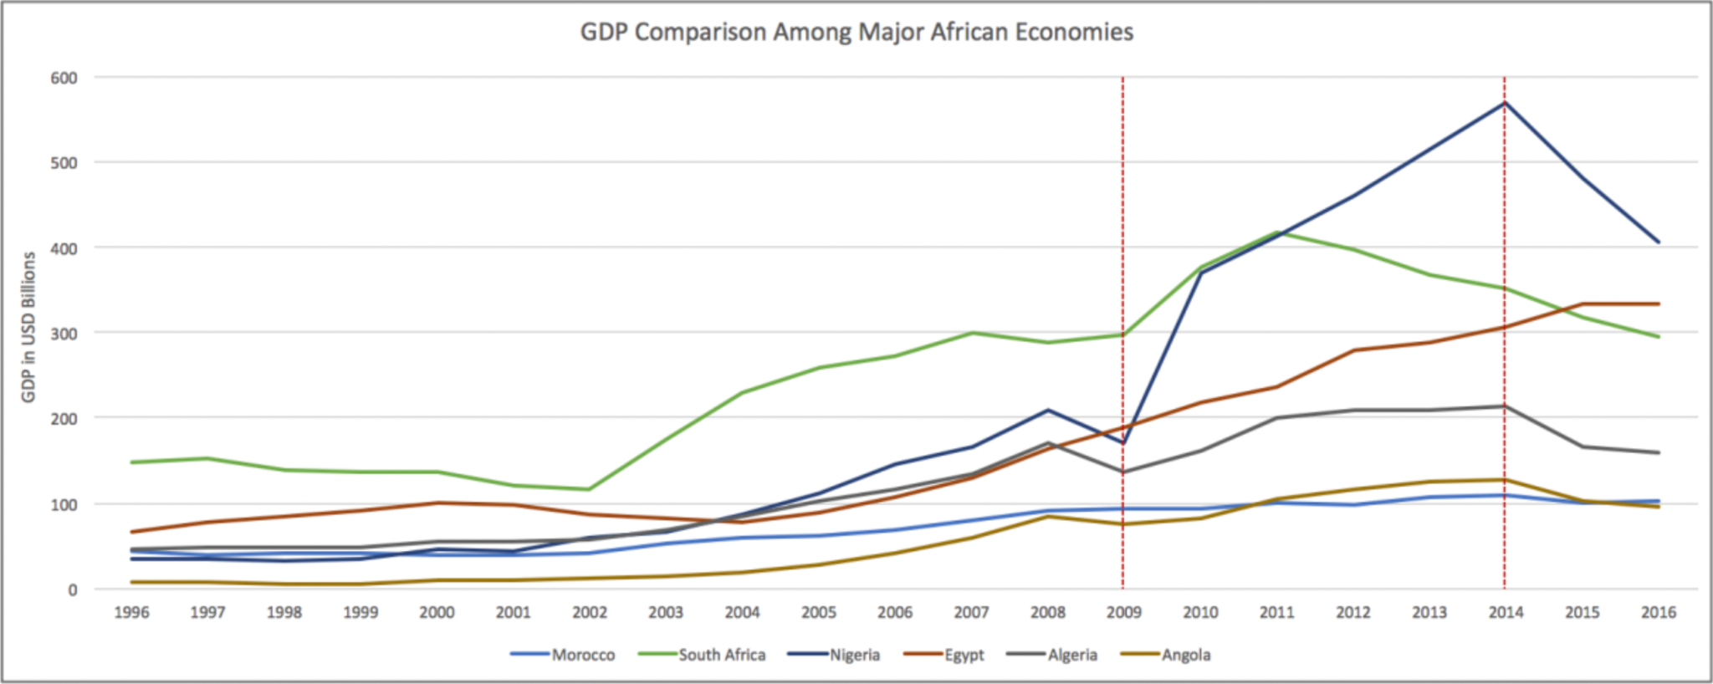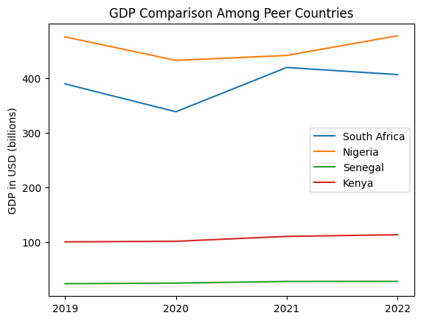
Figures 1a and 1b. GDP Comparison Among Peer Countries (left: 2013-2018; right: 2019-2022)

2.2 ECI Ranking and Changes
The Economic Complexity Index (ECI), as defined by Ricardo Hausmann and Cesar Hidalgo in 2009 to explain the knowledge accumulated in a country's population, is illustrated in Figures 2a and 2b.

As shown, South Africa exhibits a mild decrease in terms of production capability from 2013 to 2018. South Africa is in a weak position in ECI terms, as its ECI change of 171.16% is greater than Nigeria’s (115.09%), but less than both Senegal (191.47%) and Kenya (195.65%).

The comparable countries maintain a small change in ECI level between 2019 and 2020, with a sharp change between 2020 and 2022. South Africa exhibits a large increase in production capability in 2022 to levels not seen prior, with extensive microeconomic stimulus packages being one of the reasons. South Africa has seen a 171.16% increase in its ECI, which is greater than Nigeria’s (115.09%), but less than both Senegal (191.47%) and Kenya (195.65%).

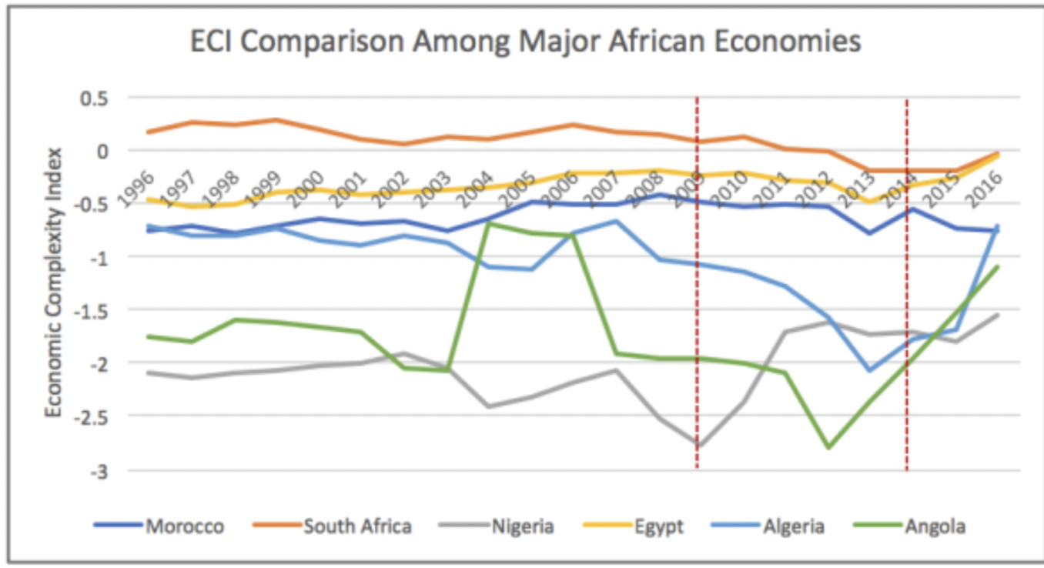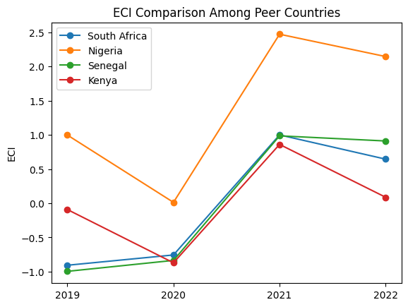
Figures 2a and 2b. ECI Comparison Among Peer Countries (left: 2013-2018; right: 2019-2022)

Figures 3a and 3b offer a further comparison of GDP Growth and ECI over the time span from 2013 to 2022 for South Africa . Similar to the GDP drop and further increase from 2013 to 2018, the GDP growth during the period from 2019 to 2022 is accompanied by a similarly volatile increase in ECI. The results show that the economic growth experienced by South Africa during the period from 2013 to 2018 is only partially consistent with the predictions by ECI and that South Africa made weak progress towards effectively developing a competitive product space that helps to accumulate complicated knowledge and technology. For the period 2019 to 2022, the ECI followed GDP trends, which can be interpreted as advancements in production. In order to provide a more concrete answer to why this has happened, we will dive into an analysis of South Africa ’s production structure and its product space designs in the next few sections.

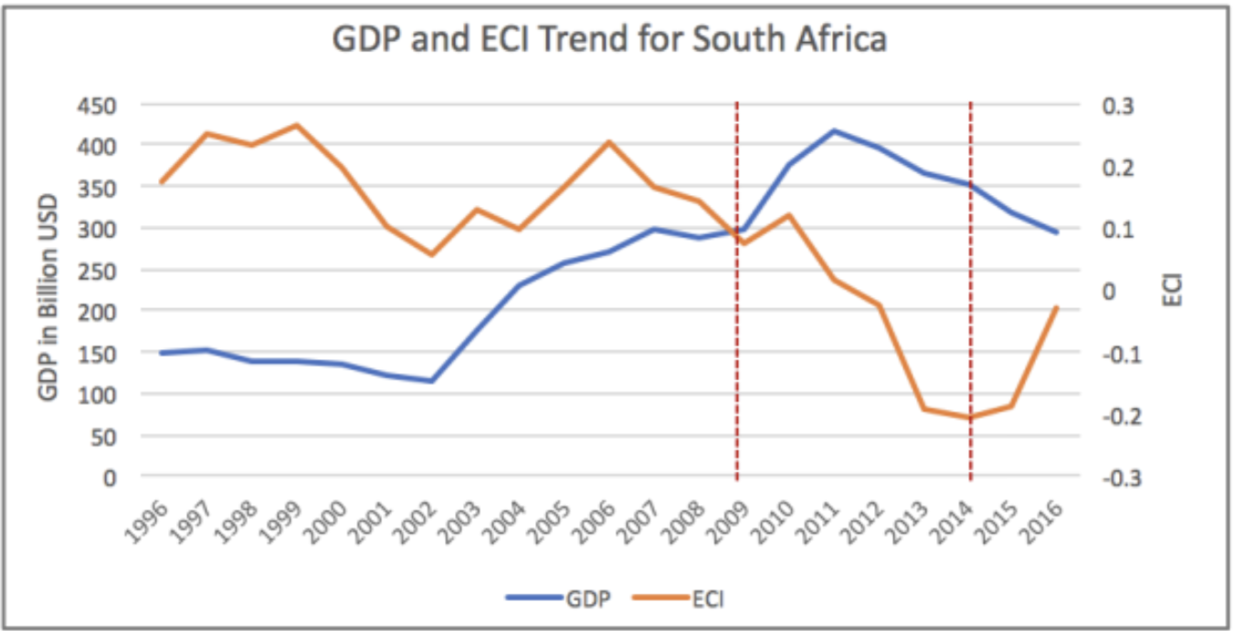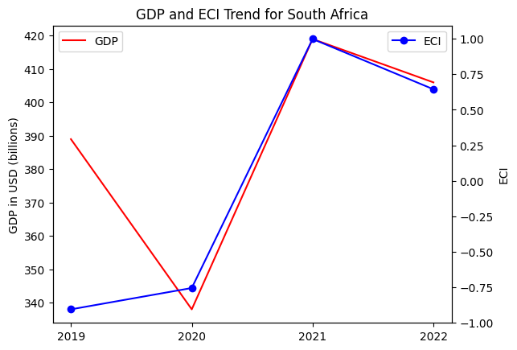Figures 3a and 3b. GDP Growth and ECI for South Africa (left: 2013-2018; right: 2019-2022)

3. Production Analysis

3.1 Product Categorization
Our main data source in this research is the UN Comtrade Website (https://comtrade.un.org), which provides us with valuable information on countries’ export values on an annual basis, including highly specific export data for more than 5000 categories of products. In order to have a holistic vision of the product space of a country, however, a level of categorization is required. Products in our data source are labeled from 010000-999999, with the first two digits representing a general category to which the product belongs. Based on the 99 categories extracted from the label, we further group the products into the 18 most widely-accepted industries, as summarized in Table 1.

Note that the High-complexity Products industry group is not a distinct industry but rather an aggregated industry that encompasses the most complicated products from the most technologically-advanced industries (as measured by PCI). This industry serves as an indicator for us to quantitatively evaluate how well a country has performed in developing cutting-edge technologies and closing its technological gap with advanced economies, which has become a topic of wide concern today. Indeed, when we rank the 18 categories based on PfCI (an equivalent concept of PCI as calculated based on the 18 categorized product groups), the High-complexity Products industry has the highest PfCI among all industry groups.

Category | Description
Animals and By-products | All kinds of meat, livestock and related by-products
Vegetables, Fruits and Plants | All kinds of plants, edible vegetables and fruits
Food and Preparations | Edible preparations, raw cooking materials and appliances
Clothing and Accessories | All kinds of fabrics, filament, clothing and accessories
Textiles | All kinds of textile articles and related products
Wood Products | Book, paper and other elementary products related to wood
Metals | Mining of all sorts of raw Metals
Refined and Processed Stones | Refined or processed stone products such as pearl and ceramics
Energy Drilling and Mining | Mining industry for energy, minerals, stone materials, etc.
Daily Instruments | Basic daily instruments such as sport requisites, timing and measuring tools
Raw Manufacturing | Basic products made from plastic, rubber, leather, etc.
Chemical Manufacturing | Advanced chemical products and pharmaceutical products
Chemicals | Raw chemical materials and by-products
Machinery and Construction | Machinery and mechanical appliances, including electrical equipment
Transportation | Vehicles and locomotives including aircraft, ship, railway, etc.
Weapons | Explosives, arms and ammunition
Services and Utilities | Financial, business, legal, communication, travel Services and Utilities, etc.
High-complexity Products | Agglomeration of advanced products with highest PCIs
Table 1. Categorization of Products

We further observe a positive correlation between the GDP and the export of High-complexity Products. A higher adjusted R-square exists between GDP and High-complexity Products exports, indicating that more successful economics, as measured by GDP, tend to be those that are capable of producing and exporting High-complexity Products as we define them. Tables 2a and 2b show the OLS results in a universe of 107 and 21 typical countries respectively.

 | High-complexity Products | Food and Preparations | Animals and By-products
Adj. R-squared | 0.075 | 0.006 | 0.002
F-statistic | 9.556 | 1.638 | 1.175
No. Observations | 107 | 107 | 107
Table 2a. OLS Regression Results of GDP against Percentage Volume of Exports

 | High-complexity Products | Food and Preparations | Animals and By-products
Adj. R-squared | 0.149 | 0.003 | -0.012
F-statistic | 4.510 | 1.059 | 0.7542
No. Observations | 21 | 21 | 21
Table 2b. OLS Regression Results of GDP against Volume of Percentage Exports

3.2 Realized Industry Development
Based on the aforementioned product categorization, we aim to capture South Africa 's realized industry production strategy between 2013 and 2022 on a complexity level. In Hausmann and Hidalgo (2009), distance is defined to be a measure of how far a country is from a certain product, not in its product space. We extend this concept to all product groups and quantify how technically equipped a country is to develop the corresponding product groups. In other words, the shorter the distance between a country and a product group, the more capable a country is of developing products within that group. Defining this net distance change as the Realized Industry Development (RID), our export data allow us to calculate and compare the RID of South Africa and the 18 product groups in 2022 and 2018 through the difference, where a positive RID indicates a shortening of the distance (i.e., advancement of the industry), and a negative RID indicates the reverse. It is notable that the number of industries with positive RID has decreased to 0 by 2022.
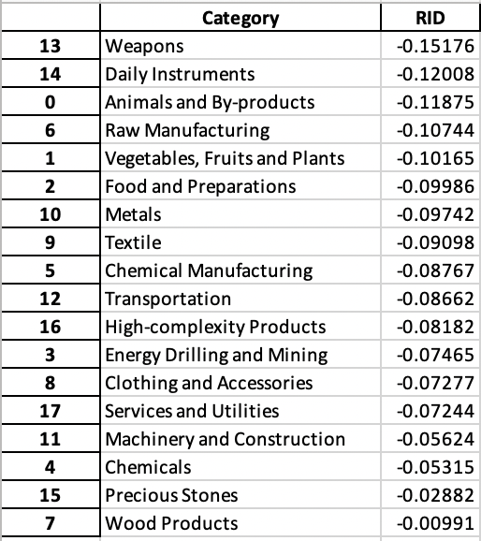
Table 3. Realized Industry Development (RID) of South Africa

3.3 Regional and Global Comparison
Tables 4a-4b below summarize how the production strategy adopted by South Africa compares with selected leading economies in the world across different years, as measured in RID. Leading economies such as France, the UK, and Germany gave a considerable level of attention to more advanced product groups such as High-Complexity Products and Food and Preparations in 2018 and Services and Utilities and Precious Stones in 2022.

Ranking | France | the UK | Germany
1 | High-complexity Products | Services and Utilities | High-complexity Products
2 | Chemical Manufacturing | Weapons | Transportation
3 | Daily Instruments | Raw Manufacturing | Wood Products
4 | Animals and By-products | Precious Stones | Metals
5 | Food and Preparations | Animals and By-products | Food and Preparations
Table 4a. RID Comparison across Leading Economies (2018)

Ranking | France | the UK | Germany
1 | Services and Utilities | Precious Stones | Daily Instruments
2 | Precious Stones | High-complexity Products | Transportation
3 | High-complexity Products | Services and Utilities | Chemicals
4 | Energy Drilling and Mining | Energy Drilling and Mining | Chemical Manufacturing
5 | Machinery and Construction | Wood Products | Clothing and Accessories
Table 4b. RID Comparison across Leading Economies (2022)

Tables 4c-4d further examine South Africa 's development strategy against those of emerging economies on a global scale. Reasonably, emerging economies such as China, South Korea, and Singapore have devoted the majority of their efforts to intermediate industry groups, showing drastic shifts in strategies over the course of four years.

Ranking | China | South Korea | Singapore
1 | High-complexity Products | Transportation | Transportation
2 | Transportation | Textile | High-complexity Products
3 | Machinery and Construction | High-complexity Products | Precious Stones
4 | Energy Drilling and Mining | Chemical Manufacturing | Daily Instruments
5 | Daily Instruments | Machinery and Construction | Services and Utilities
Table 4c. RID Comparison across Emerging Economies (2018)

Ranking | China | South Korea | Singapore
1 | Chemicals | Chemicals | Weapons
2 | Daily Instruments | Daily Instruments | Energy Drilling and Mining
3 | Transportation | Transportation | Transportation
4 | Raw Manufacturing | Textile | Machinery and Construction
5 | Weapons | Raw Manufacturing | High-complexity Products
Table 4d. RID Comparison across Emerging Economies (2022)

4. Product Space Design

4.1 Suggested Development Vector
As outlined above, distance gives us an idea of how far each new product is from a country’s current mix of exports. As defined in Hausmann and Hidalgo (2009), distance is “the weighted proportion of products connected to goods p that country c is not exporting, i.e., MCP = 0.” Based on this definition, the distance between a country and any product that the country is currently exporting (i.e., the country is a significant exporter of the product as compared to the global average) is zero. Similarly, opportunity gain quantifies the contribution of a new product in terms of opening up the doors to more and more complex products. Intuitively, a product that a country is currently exporting (i.e., MCP = 1) has an opportunity gain of zero. An unreasonable investment in a certain product p would lead to a relative decrement in the export of more profitable products and therefore lead to a negative opportunity gain of product p. The opportunity gain is not the only estimator of a country’s level of economic development. However, among countries with comparable economic strength, those having higher ECI, or in other words, more reasonable economic structures are often in better shape.

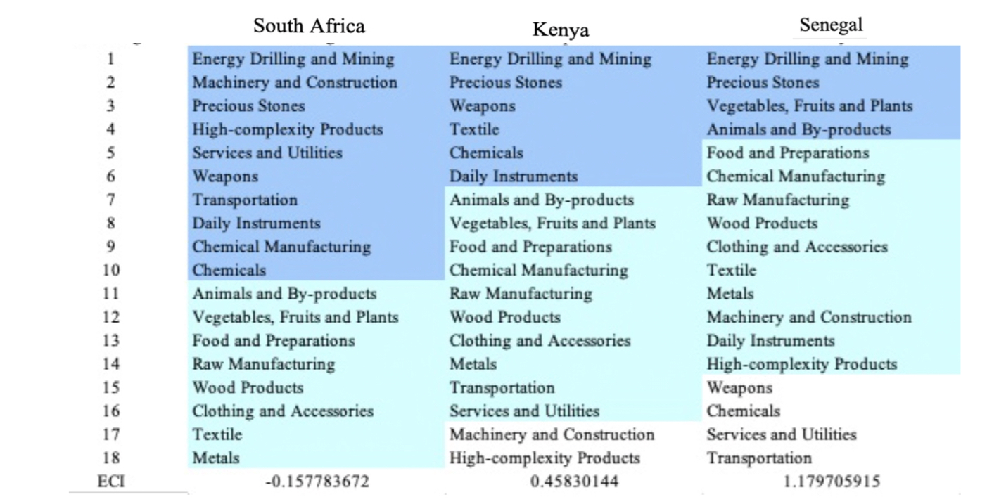
Table 5a. Opportunity Gain Ranking on a Comparable Scale (2013)
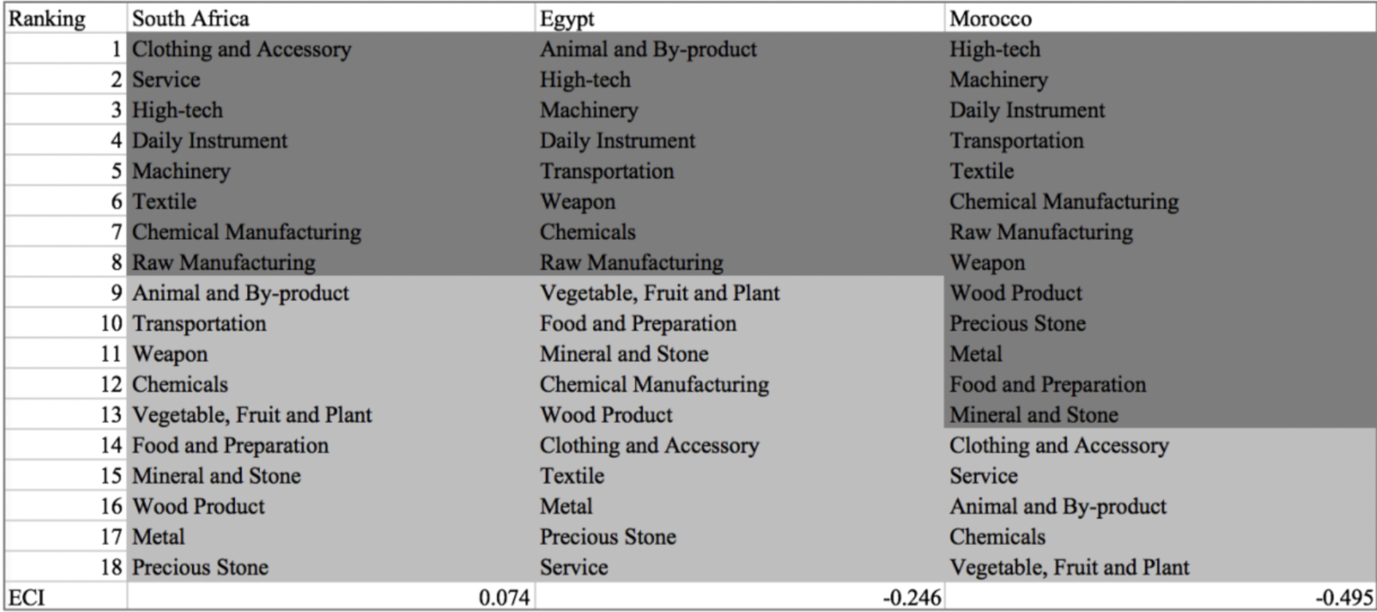
Table 5b. Opportunity Gain Ranking on a Comparable Scale (2018)
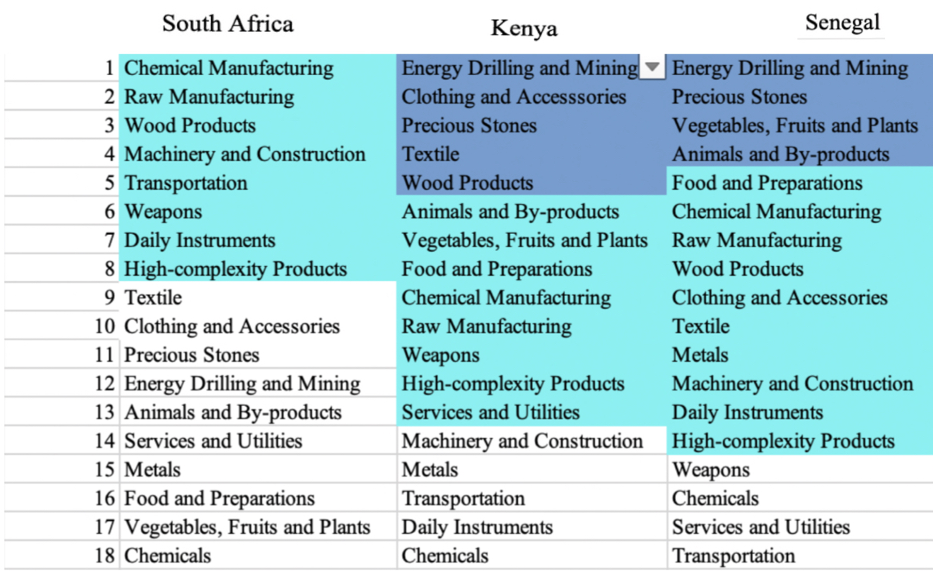
Table 5c. Opportunity Gain Ranking on a Comparable Scale (2022)

We define the ranking of opportunity gain for a country c, as the Suggested Development Vector (SDV) of c. Tables 5a-5c summarize how the SDV of South Africa compares with a selected group of comparable and leading economies in the world, with the industry groups ranked in decreasing order of significance.

Dark blue indicates positive opportunity gains, light blue indicates zero opportunity gains, and white indicates negative opportunity gains. The result shows that leading countries barely have any industries with positive opportunity gain. In other words, those countries are already in the most stable and efficient economic structure. Without the necessity of economic transition, those countries merely need to maintain a steady and balanced economic development. In contrast, developing countries have nearly half of industries with positive opportunity gain and share common interests in Animals and By Products and Energy Drilling and mining industries. It can be concluded that South Africa shares the characteristics of developing countries, with a balanced economic structure that leans towards emerging-level industries.

Table 6. SDV of Other Sample Countries (2019)

4.2 Budgeted Industry Development Strategy and Interpretation
The optimal budgeted industry development strategy aims to solve the most efficient allocations under the budgeted constraint of different situations of heuristic total export growth. In order to obtain such an allocation portfolio, we formulate an optimization problem as the following:



where k(x) is the second largest eigenvector of $M_{CC'}$ after adding $x$ to the original export vector, C is the country that we are interested in, P is the product space, B is the heuristic budget.

If we can solve this problem, then we can know what the largest ECI to which a country can improve. Accordingly, the optimal solution $x*$ that we obtain here is exactly our optimal allocation. However, the biggest problem is that the objective function is not convex. Therefore, we cannot apply the classical tools for convex optimization to this problem. In order to solve this problem, our idea is to use a greedy algorithm. The way that we apply the greedy algorithm is that firstly we separate the total budget into k equal parts, and then for the first equal part we try to search for the product that can optimize our objective function by iterating through each $p∈P$. After we find the optimal product p for this equal part, we add the amount back to the export value of this product p and update the ECI for this country. If we observe that ECI does not change after iterating all the products, then we can add up one more equal part to invest. Until we find there is an ECI increment, we add the amount now to that product. The equal rest parts can be done in the same way.

By definition, a greedy algorithm is a kind of local search algorithm that is possible to run into a local minimum. Therefore, for local search algorithms, one typical way to keep it away from the local minimum is to enhance the vision of the algorithm by looking more steps forward. In our setting, whenever we obtain an increment of ECI, we mark down the required amount of export growth. Simultaneously, we continue searching for the next ECI increment point, compare the ratios of these two possibilities and pick the largest one. The ratio is defined as the following:

where ${ECI}_{p}$ is just the ECI of the country after adding some amount of export increment to product $p$, which is exactly the amount that is able to make ECI change. Also, we can express it in the way of $||$$x_{p}-x_{0}$${||}_{1}$.

In this way, we can obtain a further sighted greedy algorithm. Also, the number of parts that we would like to separate the budget into also matters. In order to solve this problem, we added a stabilizer on top of the enhanced greedy algorithm by running the algorithm for different numbers of parts and selecting the portfolio with the largest ECI increment and most complex economic structure.

Besides, it is quite common that there is a surplus in the budget. To deal with the surplus, we just add it to the product which needs the least amount of dollars to make $M_{cp}$ = 1 (i.e., the smallest amount of required export increase).

Economic Panel
As stated above, the enhanced greedy algorithm is developed mainly for solving the optimal allocation strategy. In order to visualize this allocation, an economic panel is created, consisting of a pie chart, a line chart and a table. First, a pie chart is used to show the percentage of each product in the optimal portfolio. The number located in the center of the circle denotes the heuristic growth of total export, which is also our budget. Each category in the chart has a determined percentage of the allocated budget. The lines below the pie charts show how the ECI changes during the searching process of the greedy algorithm. Even though sometimes an increase of the export by 15% or 20% does not seem reasonable to developed countries, yet it can also give a sense of how a country should develop in the long term. Eventually, the graph in the end is just for numerical explanation for the pie charts.

Interpretation
For the purpose of a clear explanation of the line charts, we label all the products in Table 7. Please refer to this table when trying to understand the investment trajectories in the line charts.

Label | Product Names
1 | Animal and By-products
2 | Vegetables, Fruits and Plants
3 | Food and Preparations
4 | Energy Drilling and Mining
5 | Chemicals
6 | Chemical Manufacturing
7 | Raw Manufacturing
8 | Wood Products
9 | Clothing and Accessories
10 | Textile
11 | Metals
12 | Machinery and Construction
13 | Transportation
14 | Weapons
15 | Daily Instruments
16 | Precious Stones
17 | High-complexity Products
18 | Services and Utilities
Table 7. Products Labeling

Figures 4a-4c show an economic panel for South Africa in 2013, 2018, and 2022. We can see that for different percentages of heuristic total export growth, the ECIs of South Africa actually have different increments.

For 2013, in the case of 5 percent export growth, Raw Manufacturing is one of the main components. With a budget of 10 percent export growth, Textile accounts for most of the portfolio. Meanwhile, for 15 and 20 percent export growth scenarios, Textile and Machinery and Construction account for most of the portfolio. A more detailed numerical representation of the portfolio is shown in Table 8a.
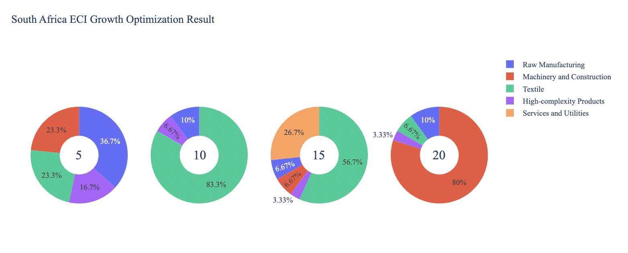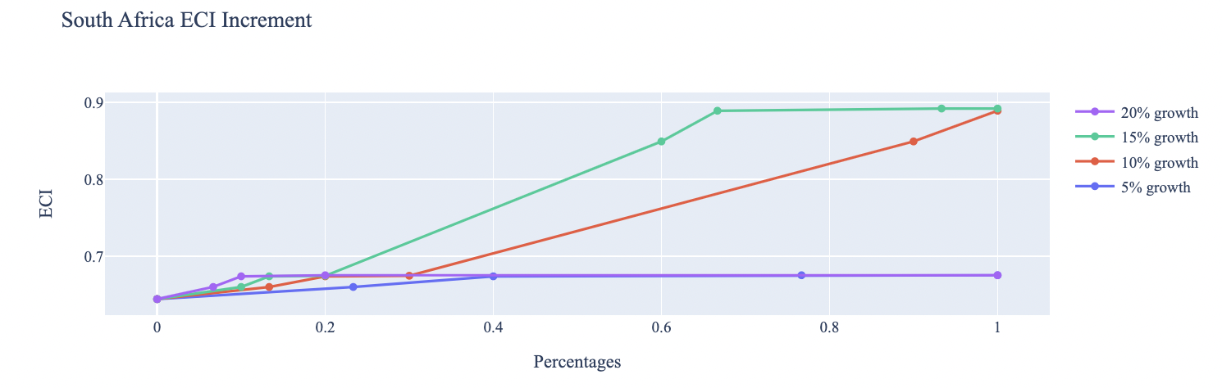

Figure 4a. Greedy-Based ECI Improvement Results of South Africa with Different Budgets (2013)

South Africa (2013)
Original ECI | 0.36
Heuristic Export Growth | 5% | 10% | 15% | 20%
Services and Utilities | 0 | 0 | 58581939363 | 0
High Complexity Products | 1038089922 | 0 | 0 | 26934224994
Textile | 1.6609E+10 | 4.0121E+10 | 14645484841 | 33667781243
Machinery and Construction | 0 | 0 | 0 | 20200668746
Raw Manufacturing | 2076179843 | 7294685936 | 9763656560 | 1023949012
Increased ECI | 1.1419E+10 | 6.2005E+10 | 63463767643 | 16833890621
South Africa (2013)
Table 8a. Portfolio of South Africa (2013)

For further suggestions on South Africa ’s development in the future, we also offer the optimization result based on its export data in 2018. Below is the economic panel for South Africa in 2018. A more detailed numerical representation of the portfolio is shown in Table 8b.

Figure 4b. Greedy-Based ECI Improvement Results of South Africa with Different Budgets (2018)

South Africa (2018)
Original ECI | 0.36
Heuristic Export Growth | 5% | 10% | 15% | 20%
Services and Utilities | 0 | 0 | 58581939363 | 0
High Complexity Products | 1038089922 | 0 | 0 | 26934224994
Textile | 1.6609E+10 | 4.0121E+10 | 14645484841 | 33667781243
Machinery and Construction | 0 | 0 | 0 | 20200668746
Raw Manufacturing | 2076179843 | 7294685936 | 9763656560 | 1023949012
Increased ECI | 1.1419E+10 | 6.2005E+10 | 63463767643 | 16833890621
South Africa (2018)
Table 8b. Portfolio of South Africa (2018)

To compare with the performance in 2013 and 2018, we also re-examine suggested strategies for 2022. For 2022, a 5 percent increase in export would emphasize Services and Utilities, followed by High Complexity Products, Textile, Machinery and Construction, and Raw Manufacturing for 10, 15, and 20 percent export growth respectively. These strategies go in line with the suggested trajectories based on ECI. A more detailed numerical representation of the portfolio for South Africa is shown in Table 8c.
Figure 4c. Greedy-Based ECI Improvement Results of South Africa with Different Budgets (2022)

South Africa (2022)
Original ECI | 0.36
Heuristic Export Growth | 5% | 10% | 15% | 20%
Services and Utilities | 0 | 0 | 58581939363 | 0
High Complexity Products | 1038089922 | 0 | 0 | 26934224994
Textile | 1.6609E+10 | 4.0121E+10 | 14645484841 | 33667781243
Machinery and Construction | 0 | 0 | 0 | 20200668746
Raw Manufacturing | 2076179843 | 7294685936 | 9763656560 | 1023949012
Increased ECI | 1.1419E+10 | 6.2005E+10 | 63463767643 | 16833890621
South Africa (2022)
Table 8c. Portfolio of South Africa (2022)

4.3 Sensitivity Analysis and Contingency Strategy
In the following section, our broad aim is to understand how sensitive South Africa is to changes in export in various industries. While the Economic Complexity Index has been shown to contain valuable information about the economic strength/capacity of a country, little has been said as to the stability of the measure itself. We seek to uncover the main drivers of stability under a country's ECI score and better understand longer-term projections for ECI growth. Additionally, gaining an intuition on the industries that are bolstering an economy and the industries that offer the greatest return per unit of investment is best done through visualization of industry-specific sensitivity. To this end, we have developed two categories of sensitivity analysis.
ECI Sensitivity Graph
First, in order to assess the effect particular industries have on each respective country, we developed ECI Sensitivity graphs (Figure 5). We use the shocking methodology to increment or decrement an industry’s export level by a certain percentage and recalculate the ECI, all else being equal. While freezing the export dynamics of the rest of the world and enacting an instantaneous shock in export for a particular industry and country may not reflect real-life dynamics, what it does offer us is an understanding of a country’s level of dependency on an industry in the context of ECI. The shocking is done in small percentage increments in order to smooth out the resulting curve. Additionally, a recurring theme one will see is that for most industries, a breaking point occurs where the ECI either jumps upwards or downwards, creating a hockey stick shape rather than a linear trend. While the inflection point may not be accurate in the context of real life, comparing the various inflection points across industries can give us valuable insight.

Figure 5. Sample ECI Sensitivity Graph (2018)
The graphs are formulated as follows. There are six ECI Sensitivity graphs, two for each of the following years: 2022, 2018, and 2013. The first chart, Incremental ECI Sensitivity, shows positive shocking in which export numbers are shocked upwards per industry. The X-axis is in terms of percentage shock per current dollar value of export. The Y-axis is the recalculated ECI level post-shocking. The second chart, Decremental ECI Sensitivity, follows the same format except the X-axis represents negative shock. In other words, exports for each industry are decremented, and the ECI is accordingly recomputed.

SDV Sensitivity
Secondly, we analyze the sensitivity of the SDV to changes in export levels. The goal is to understand how export level changes for a particular industry can affect the marginal opportunity gain for other industries. We will be using specifically High Complexity Products and Food and Preparations as our base industries. We will be increasing or decreasing the absolute export level in both of these industries and observing the effects on the SDV.
When the opportunity gain of an industry is negative, the SDV sensitivity approximates how an over-development of the industry jeopardizes the economic structure of a country. When the opportunity gain of the industry is zero, the SDV sensitivity determines whether the further development of the industry shapes the country with a better economic structure and predicts how the SDV would change accordingly. Specifically, as we reduce the export of such an industry to 25% - 50% of its original value, a few other industries originally with negative opportunity gain could likely become profitable.
Similar to the ECI sensitivity graphs above, we will be shocking the export of High Complexity Products and Food and Preparations in small percentage increments. A new SDV, represented by a new column in the charts, is recorded only when a certain level of shock changes the structure of the SDV. In effect, we are incrementing or decrementing export levels of two industries until the marginal opportunity gain of any industry changes in category (positive, negative, or neutral). Below is an example of an SDV Sensitivity chart with Positive Shocking. Industries with positive marginal opportunity gain are colored blue, neutral is colored white, and negative is colored red.


Table 9. Sample Incremental SDV Sensitivity for High-Complexity Products (2018)

Contingency Plan
The Contingency Plan aims to present a set of solutions with respect to upheavals in different industries. Instead of compensating for the declining production directly, the best strategy is to develop those incipiently profitable industries. In this manner, we can derive a contingency strategy for countries to deal with possible abrupt declines of crucial industries. In some cases, the SDV remains unchanged even when a zero-opportunity-gain industry declines to 20% in terms of export. We can then conclude the industry is not indispensable to the country. As a clarification, the three consecutive N/As mean that the country doesn’t even need to respond to a collapse in the industry. Countries tend to have distinct solutions to the ups and downs of the same industry. To create the contingency strategy table, we decrease the export level for each industry in the country’s current production space by 60% respectively. The three highest-ranking industries in the new SDV are then returned.

Product Names | 0 | 1 | 2
Animal and By-products | Services and Utilities | Daily Instruments | Weapons
Vegetables, Fruits and Plants | Services and Utilities | Daily Instruments | Weapons
Food and Preparations | Services and Utilities | Daily Instruments | Weapons
Energy Drilling and Mining | Services and Utilities | Daily Instruments | Weapons
Chemicals | Services and Utilities | Daily Instruments | Weapons
Chemical Manufacturing | Services and Utilities | Daily Instruments | Weapons
Raw Manufacturing | Services and Utilities | Daily Instruments | Weapons
Wood Products | Services and Utilities | Daily Instruments | Weapons
Clothing and Accessories | Services and Utilities | Daily Instruments | Weapons
Textile | Services and Utilities | Daily Instruments | Weapons
Metals | Services and Utilities | Daily Instruments | Weapons
Machinery and Constructions | Services and Utilities | Daily Instruments | Weapons
Transportation | Services and Utilities | Raw Manufacturing | Daily Instruments
Weapons | Services and Utilities | Daily Instruments | Transportation
Daily Instruments | Services and Utilities | Weapons | Transportation
Precious Stones | Services and Utilities | Daily Instruments | Weapons
Daily Instruments | Services and Utilities | Daily Instruments | Weapons
Services and Utilities | Daily Instruments | Weapons | Transportation
Table 10. Sample Contingency Strategy (2018)

4.3 Sensitivity Analysis Results and Interpretation
We examine South Africa 's ECI Decremental and Incremental Sensitivity Charts for 2022. An increase in Energy Drilling and Mining will lead to the highest change in ECI, followed by Chemical Manufacturing, and Animal and By-products. The strong sensitivity effect of manipulating the Energy Drilling and Mining category remains consistent with previous years. For the negative shock cases, Weapons, Precious Stones, and Raw Manufacturing become most impactful, remaining consistent with the previous years]. The rest of the industries do not appear to have the same level of sensitivity.

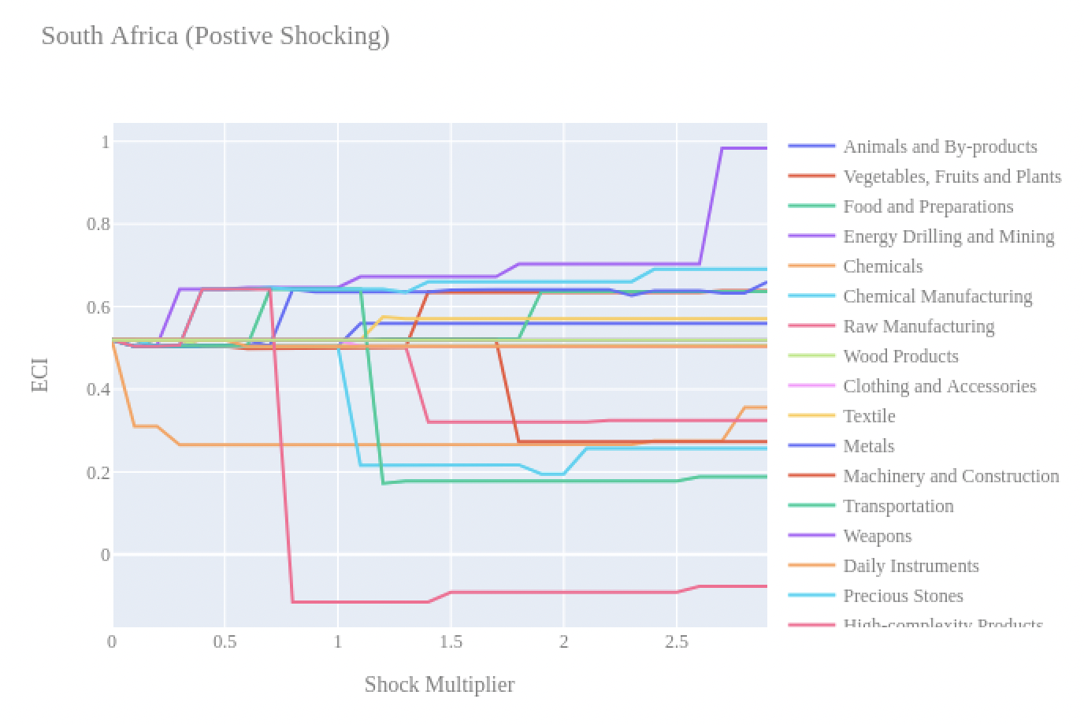
Figure 6a. Incremental ECI Sensitivity for South Africa (2022)
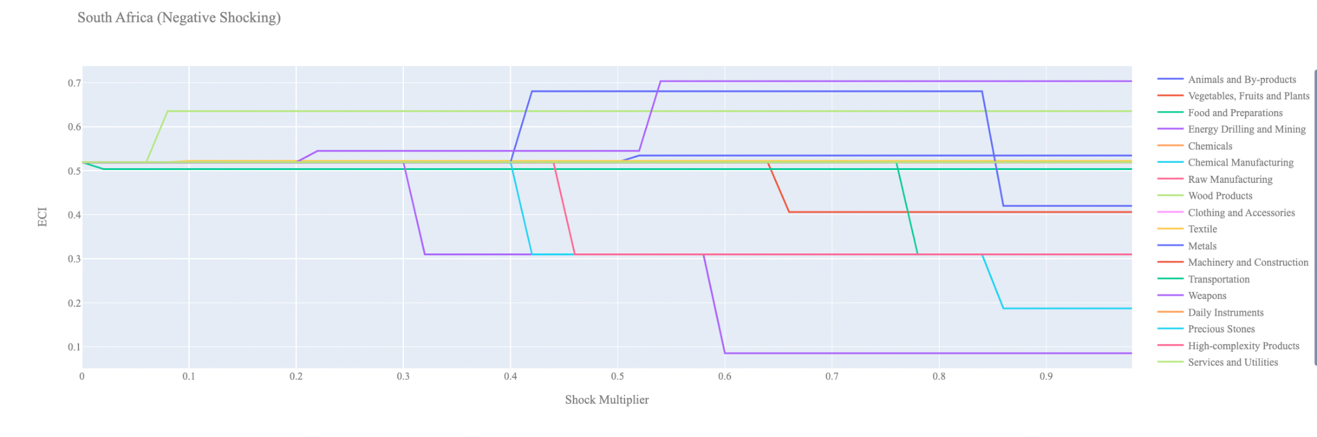
Figure 6b. Decremental ECI Sensitivity for South Africa (2022)

Below is South Africa 's 2018 ECI Sensitivity Charts. First, in the positive chart, we notice immediately that increases in Energy Drilling and Mining, Chemical Manufacturing, and Animal and By-products lead to an uptrend of ECI. Energy Drilling and Mining and Chemical Manufacturing seem to give the most immediate increase in ECI for only a 20-30% increase in export magnitude.

Next, we consider South Africa 's 2018 Negative Shock chart. We see that South Africa is sensitive to changes in export levels in Weapons, Precious Stones, and Raw Manufacturing as well as Daily Instruments and Food and Preparations. Interestingly, South Africa is highly insensitive to changes in most other industries suggesting that South Africa has a good blend of industries that complement each other and are able to compensate for reductions in other industries.
Figure 7a. Incremental ECI Sensitivity for South Africa (2018)

Figure 7b. Decremental ECI Sensitivity for South Africa (2018)

Next, we consider the 2013 ECI Sensitivity graphs (Figures 8a and 8b). We see that in the positive shocking case, the landscape of ECI sensitivity has not altered significantly over the three-year period. Weapons, Precious Stones, and Raw Manufacturing as well as Daily Instruments and Food and Preparations lead to an uptrend in ECI. However, we see that in 2018 South Africa seems to be highly sensitive to increases in Energy Drilling and Mining.

In the 2013 negative shocking case, we see that again South Africa is very sensitive to drawbacks in Weapons, Precious Stones, and Raw Manufacturing as well as Daily Instruments and Food and Preparations. Again, we see that South Africa is highly insensitive to drawdowns in the majority of its industries. However, unlike the 2018 case, we see quite a bit of sensitivity to Energy Drilling and Mining.
Figure 8a. Incremental ECI Sensitivity for South Africa (2013)

Figure 8b. Decremental ECI Sensitivity for South Africa (2013)

Below we see the SDV sensitivity charts for High Complexity Products. We see that fairly small increases in export of High Complexity Products makes room for other industries to shift into positive opportunity gain territory. A 50% increase in export leads to 10 new industries that offer positive opportunity gain, some of which include Chemicals, Services and Utilities, Daily Instruments, Textile, and Transportation.

Considering the Negative SDV sensitivity chart we observe that as exports of High Complexity products decrease, industries that were worth investing in begin to shift to the neutral opportunity gain region. At the extreme case we see that Services and Utilities and Machinery become the best industries to pursue after a major decrease in High Complexity products.

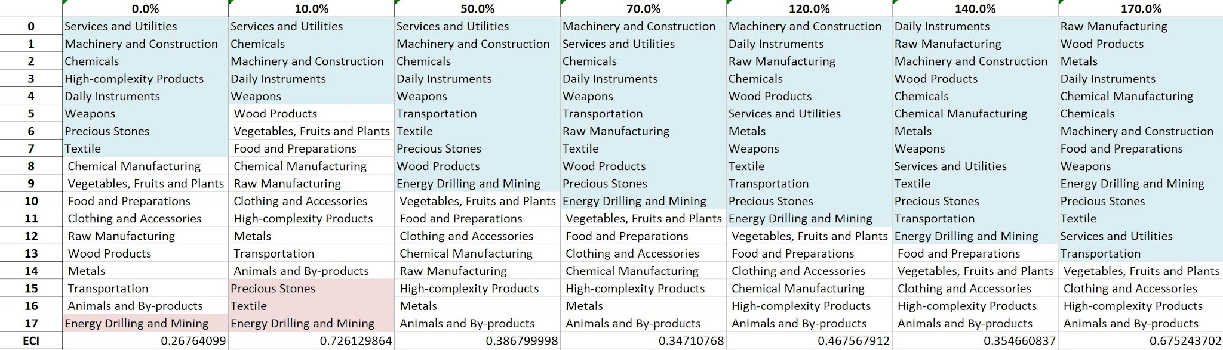Table 11. South Africa ’s SDV Sensitivities for High Complexity Products(2018)
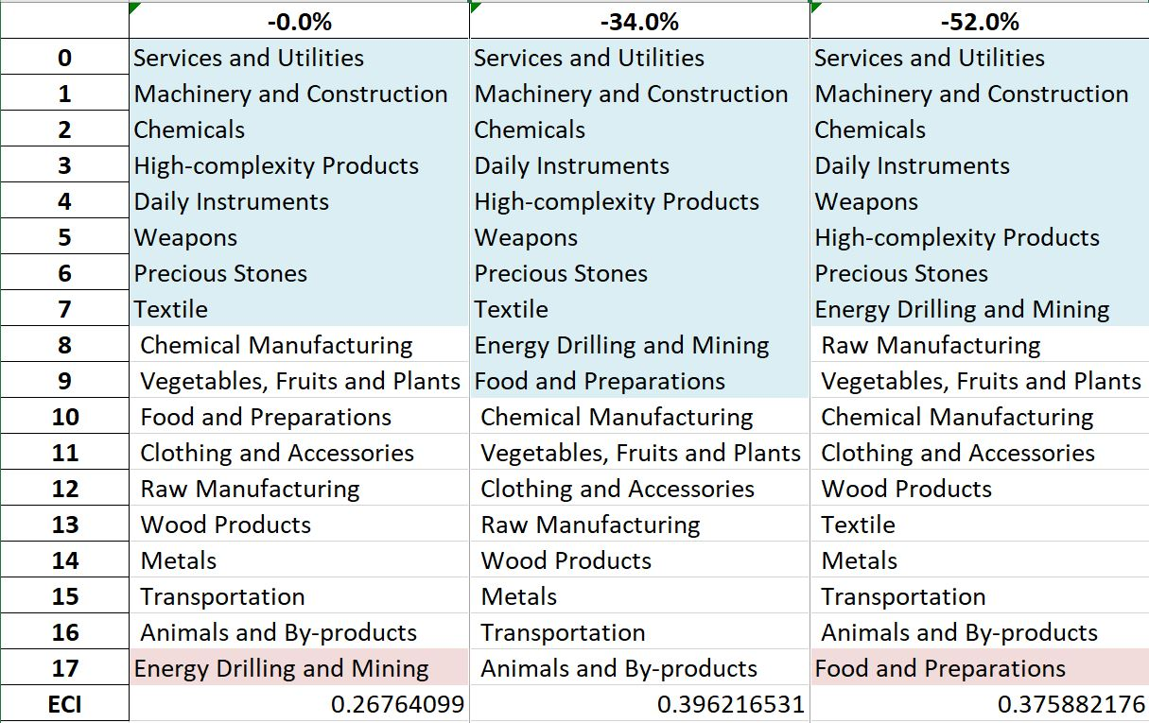
Table 12. South Africa ’s SDV Sensitivities for Food and Preparations(2018)

4.4 Contingency Strategy
Decreasing export of each industry in South Africa ’s current production space by 60% respectively, we derive the contingency strategy shown below.

Product Names | 0 | 1 | 2
Animal and By-products | Services and Utilities | Machinery and Construction | Chemicals
Vegetables, Fruits and Plants | Services and Utilities | Machinery and Construction | Chemicals
Food and Preparations | Services and Utilities | Machinery and Construction | Chemicals
Energy Drilling and Mining | Services and Utilities | Machinery and Construction | Chemicals
Chemicals | Services and Utilities | Machinery and Construction | Chemicals
Chemical Manufacturing | Services and Utilities | Machinery and Construction | Chemicals
Raw Manufacturing | Services and Utilities | Machinery and Construction | Chemicals
Wood Products | Services and Utilities | Machinery and Construction | Chemicals
Clothing and Accessories | Services and Utilities | Machinery and Construction | Chemicals
Textile | Services and Utilities | Machinery and Construction | Chemicals
Metals | Services and Utilities | Machinery and Construction | Chemicals
Machinery and Construction | Services and Utilities | Machinery and Construction | Chemicals
Transportation | Services and Utilities | Machinery and Construction | Chemicals
Weapons | Services and Utilities | Machinery and Construction | Chemicals
Daily Instruments | Services and Utilities | Machinery and Construction | Chemicals
Precious Stones | Services and Utilities | Machinery and Construction | Chemicals
High-complexity Products | Services and Utilities | Machinery and Construction | Chemicals
Services and Utilities | Services and Utilities | Machinery and Construction | Chemicals
Table 13. South Africa ’s Contingency Strategy (2018)

5. Macro-level Predictions

5.1 Structural Optimality Index
ECI sensitivity described in the section before has proven to be a significant factor in deciding the economic outcomes of countries. In order to quantitatively evaluate how effective our development strategies are and how deviations from the suggested developmental path will lead to suboptimal growth results, we define the measure – Structural Optimality Index (SOI) – on a country level as the Adjusted R-Square obtained from regressing the country’s realized industry development over the suggested development strategy. Both strategies are quantified in nature, with the realized development represented by increasing export in every major industry group and the suggested development strategy represented by the opportunity gains of developing the corresponding industry groups as calculated in previous sections. The adjusted R-square from the regression thus provides us with a quantified measure of how the development path adopted by the country has fitted with/differed from calculations on a complexity level.

After obtaining this measure for all countries in our database, we further regress countries’ five-year economic growth, which is defined as the percent increase in GDP (USD), over their SOI. Figure 9 illustrates the regression output, which shows a strong positive correlation between countries’ SOI and their five-year GDP growth, significant at the 0.7% level and achieving an adjusted R² of -0.4%. In other words, the more a country develops, as suggested by calculations on a complexity level, the better economic outcomes it achieves.

Table 14: OLS Regression Results
Dep. Variable: GDP | F-Statistic: 0.6524
R²: 0.007 | Prob (F-Stat): 0.421
Adj R²: -0.004 | No. Observations: 100


Figure 9. Regression of Five-Year GDP Growth over SOI (2013-2018)

5.2 SOI of South Africa and Its Implications
During the first examined period, South Africa , for instance, has a low level of structural optimality as compared with its developed peers. As the regression in Figure 10a suggests (the red curve represents export increase and the blue curve stands for opportunity gain of the corresponding industry), South Africa demonstrates a low level of correlation with the suggested developmental path, having an adjusted R-square of around -0.004.

South Africa ranks in the lowest quartile among all countries in terms of SOI and has made a slow rate of economic progress among its emerging peers from 2013 to 2018 with a 5-year GDP growth rate of 3.39%, which is consistent with the regression result in Figure 4b. This is in direct contrast to emerging economies such as Kenya, where there is a high SOI of around 4.67% and corresponding GDP growth of 8.98% from 2013 to 2018, making it one of the fastest developing economies during the period.

Specifically, South Africa 's slow economic progress from 2013 to 2018 can be at least partially explained by a development strategy that demonstrates a considerable but not perfect level of matches with our suggested developmental path. In specific, South Africa invested heavily in the precious stones industry, while it should have focused more on industry groups such as high-tech.

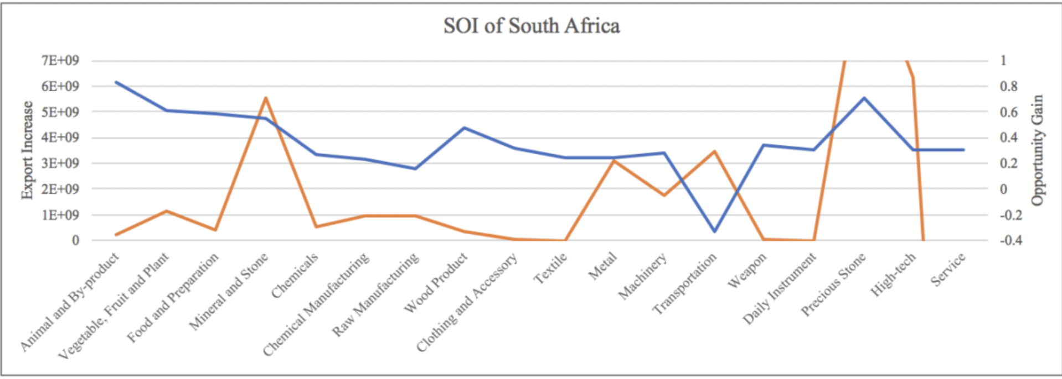
Figure 10a. SOI of South Africa (2013-2018)

For the 2019-2022 years, South Africa has a strong presence in the High Tech and Precious Stone industries, but they seem to be overdeveloped when considering their lower opportunity gain relative to RID. It also could consider Food and Preparation and Mineral and Stone to improve its growth. South Africa has seen a decline in GDP over those three industries. South Africa also ranked among the lowest quartiles among all countries in terms of SOI.

Lower than before, its adjusted R-squared value of -0.004 indicates a low correlation between the GDP growth and the implemented development path. Progress is slow on a global scale during this period, but South Africa demonstrates a low ability to adjust to negative economic shocks by improving SOI and increasing GDP growth than it did between 2013 and 2018.

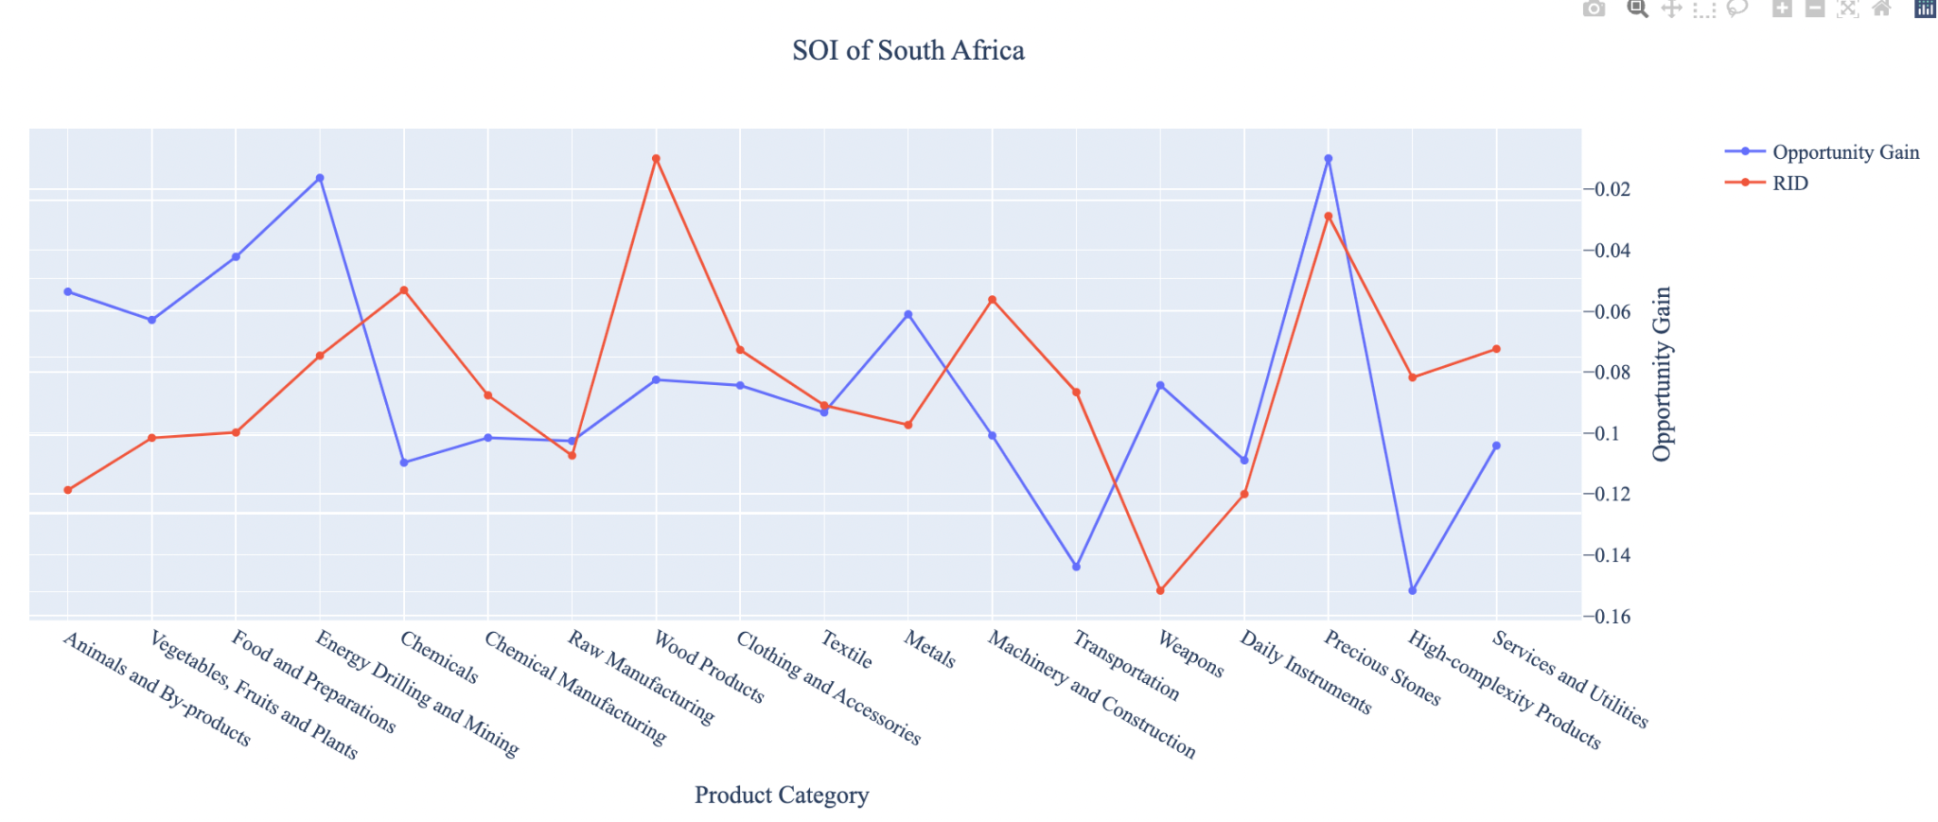
Figure 10b. SOI of South Africa (2019-2022)

6. Concluding Remarks

In conclusion, South Africa has demonstrated a low level of economic growth in terms of annual GDP increase during the period from 2013 to 2018, concurrent with an increase in economic complexity as compared with major developed economies. For 2019-2022, the growth in GDP has increased alongside a small boost in ECI, slightly less than its comparable countries and higher than some of the leading economies in the world.

We believe that the mixed progress during the first period can be partially explained through the analysis of the economic and product complexity structure of South Africa on the industry group level. The product classification system we adopt allows us to measure the realized industry development for various industry groups and to observe that South Africa regressed in developing most of its industries during the period, while its developed counterparts and emerging economies around the globe adopted much more complex and progressive paths.

Based on our analysis of the opportunity gain and sensitivity analysis of major industry groups for 2013-2018, South Africa can further its gains by prioritizing Weapons, Precious Stones, and Raw Manufacturing. We further note that South Africa has a heavily mismatched development strategy that indicates a low level (compared to other emerging countries) of structural optimality on the complexity level, having an adjusted R-square of around -0.4%. Since a negative exists between five-year GDP growth and the structural optimality index of an economy as we define and calculate, South Africa indeed has a suboptimal growth experience as compared with fast-growing economies both on a regional scale and on a global scale and has the potential to further its economic gains through industrial structure optimization as suggested in the paper.

During the second examined period from 2019 to 2022, South Africa performed much weaker than before and compared to other countries, particularly Kenya. We infer that during the COVID-19 period, South Africa focused on developing lower complexity industries, in line with lower demand for these industries given the global economic downturn. We also note that South Africa has increased its investment in the sectors identified earlier, leading to a strong boost from Wood Products and Machinery and Construction industries, leaving some room for strategic improvement. It did invest in the industries which contributed the most to its advancements, such as Wood Products and Machinery and Construction industries. The ECI suggests that greater growth could have been achieved through High Tech and Energy Drilling and Mining industries. The surprising growth also increased the adjusted R-squared value to -0.001 in 2022 from -0.004 in 2018, demonstrating the pursued strategies contributed to the GDP. With the revised focus, South Africa has further potential to advance its economic growth to maintain its position among other countries to continue its post-pandemic recovery.

References

Hausmann, R., Hidalgo, C., Bustos, S., Coscia, M., Chung, S., Jimenez, J., Simoes, A. and Yıldırım, M. (2007). The Atlas of Economic Complexity. [online] Atlas.cid.harvard.edu. Available at: http://atlas.cid.harvard.edu/.

Balassa, B., “The Purchasing Power Parity Doctrine - A Reapprais- al,” Journal of Political Economy 72, 584-596 (1964).

Feenstra, R.; Lipsey, R.; Deng, H.; Ma, A. & Mo, H. “World Trade Flows: 1962-2000” NBER working paper 11040. National Bureau of Economic Research, Cambridge MA (2005).

United Nations Commodity Trade Statistics Database (http://comtrade.un.org/db/), accessed in August 2019.

The World Economic Forum, “The global competitiveness report,” (various years).

Barro, R. & Lee, J-W. “A New Data Set of Educational Attainment in the World, 1950-2010,” NBER Working Paper No. 1590 (2010).

Kaufmann, D. & Kraay, A. “Governance Indicators: Where Are We, Where Should We Be Going?” Policy Research Working Paper 4370. Washington, DC: World Bank (2008).

Hanushek, E.A. & Woessmann, L. “The Role of Cognitive Skills in Economic Development,” Journal of Economic Literature 46(3), 607- 668 (2008).

